Word of Life: May 2023
Recommended dates are provided, but you are welcome to use these materials at any time!
Featured this Month…
May 14, 2023: Mother’s Day
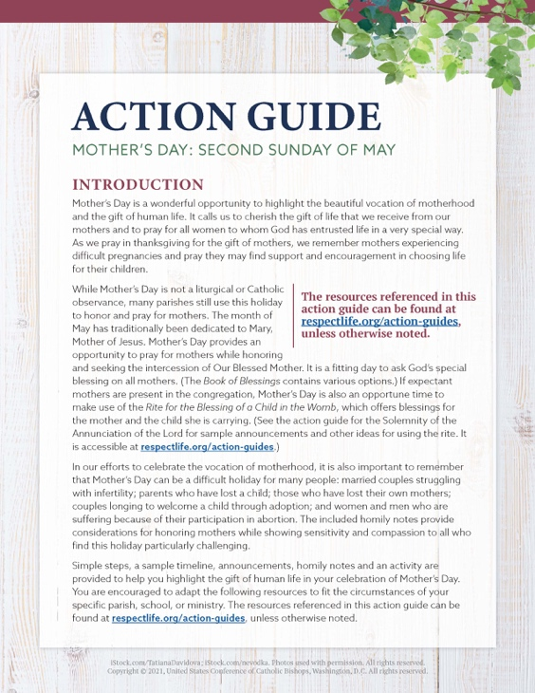
Mother’s Day is a wonderful opportunity to highlight the beautiful vocation of motherhood and the gift of life.
Our Mother’s Day action guide features homily considerations, intercessions, activity ideas, and more to assist with honoring and praying for mothers in your parish community.
A webinar recording of USCCB staff walking through the materials, as well as the presentation slides, are available.
*You’re welcome to use one component of the action guide or the whole thing—whatever’s helpful!

May 31, 2023: Feast of the Visitation of the Blessed Virgin Mary
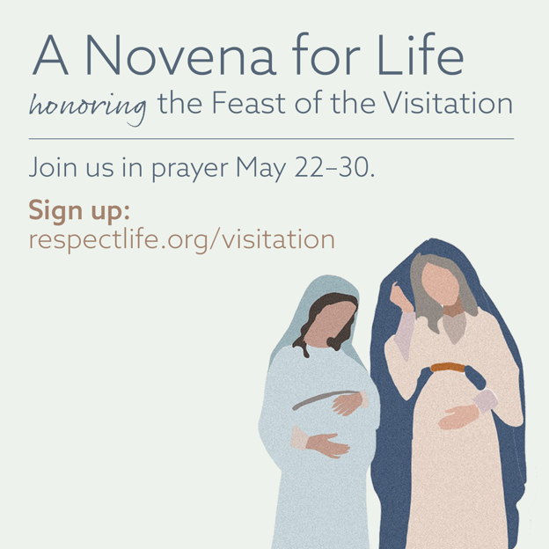
On May 31st, the Church celebrates the Feast of the Visitation of the Blessed Virgin Mary. This feast commemorates the Blessed Mother’s visit to her cousin Elizabeth and the encounter of Jesus and St. John the Baptist while in the wombs of their mothers. Join us in praying A Novena for Life in honor of this special feast day.

Suggested Date for Graphic/Announcement: Weekends of May 13-14 and May 20-21, 2023
Download Graphic

Sample Announcement:
Join a Novena for Life honoring the Feast of the Visitation. Sign up at respectlife.org/visitation!

Word of Life – May 2023

Intercessions for Life
May 7th  For those in public office:  May they work to enact laws  that protect and safeguard  the gift of human life;  We pray to the Lord: | Fifth Sunday of Easter
May 14th  For mothers:  That they may be recognized and supported  in this special vocation;  We pray to the Lord: | Sixth Sunday of Easter  (Mother’s Day is not a liturgical feast but is often recognized at Mass.)
May 21st  For all Christians:  That our example may give witness to  the precious gift of human life in this world and  the invitation to eternal life in the next;  We pray to the Lord: | Solemnity of the Ascension of the Lord  (or the Seventh Sunday of Easter where applicable)
May 28th  May the Holy Spirit strengthen God’s people  to embrace and protect  the precious gift of human life;  We pray to the Lord: | Pentecost Sunday

Word of Life – May 2023
Bulletin Quotes
May 7th  “Without a foundational, practical formation, it is difficult for our consciences to guide us well in concrete situations. As Catholics, we have the immense gift of the teaching authority of the Catholic Church and can turn to it for help forming our consciences. For example, learning about Christian moral principles, reading the Catechism of the Catholic Church, or researching what the Church says about a challenging teaching will help us grow in knowledge of the truth.”  USCCB Secretariat of Pro-Life Activities, “Understanding Conscience” | 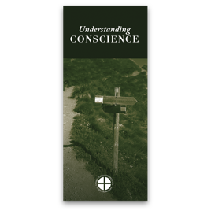  Order | Download
May 14th  “O Blessed Mother, you received the good news of the incarnation of Christ, your Son, with faith and trust. Grant your protection to all pregnant mothers facing difficulties.”  USCCB Secretariat of Pro-Life Activities, “A Prayer for Pregnant Mothers” | 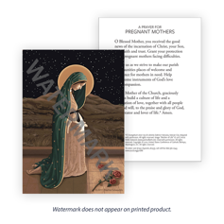  Order | Download
May 21st  “The Lord says to us, ‘Do not fear: I am with you’ (Isaiah 41:10). He speaks these words not as one who merely observes our pain, but as one who experienced immense suffering. And the very wounds that bear witness to his suffering indicate the essence of our identity and worth: we are loved by God. Reflecting on the healed wounds of the Risen Christ, we see that even our most difficult trials can be the place where God manifests his victory. He makes all things beautiful. He makes all things new.”  USCCB Secretariat of Pro-Life Activities, “Be Not Afraid”  NABRE © 2010 CCD. Used with permission. | 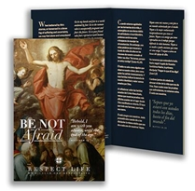  Order | Download
May 28th  “Even the weakest and most vulnerable, the sick, the old, the unborn and the poor, are masterpieces of God’s creation, made in his own image, destined to live forever, and deserving of the utmost reverence and respect.”  USCCB Respect Life flyer quoting Pope Francis’ “Day for Life Greeting”  © 2013 Libreria Editrice Vaticana. Used with permission. All rights reserved. | Order | Download

Word of Life – May 2023
Bulletin Art
You are welcome to use these images, provided they are not altered in any way, other than the size. Thank you!

Sunday, May 14th, 2023
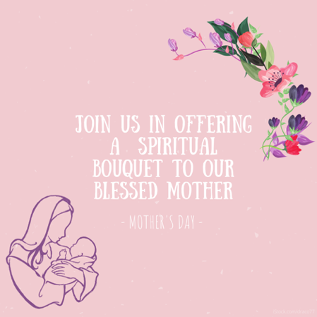
Download Image

Spiritual Bouqet Activity Instructions: Select “Activity (with at-home option)” from the list of documents on this page.

Sunday, May 21st, 2023
(The novena begins Monday, May 22, and the Feast of the Visitation of the Blessed Virgin Mary is Tuesday, May 31.)

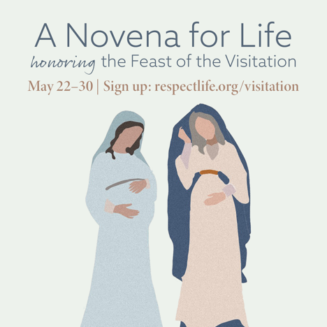
Download Image(s)

Sample Announcement:
Join a Novena for Life honoring the Feast of the Visitation. Sign up at respectlife.org/visitation!

Sunday, May 28th, 2023
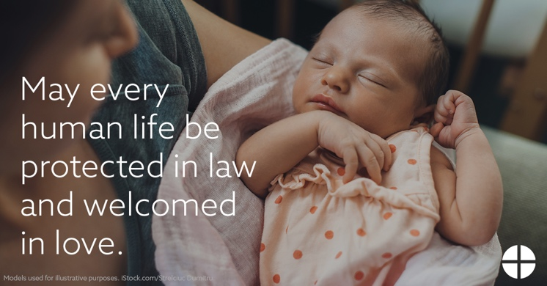
Download: English | Spanish

