Word of Life: November 2022
Recommended dates are provided, but you are welcome to use these materials at any time!
Featured this Month…
National Hospice and Palliative Care Month
This is a great opportunity to highlight the topics of hospice, palliative care, and other end-of-life topics. The following resources are available:
- Catholic Care for the Sick and Dying
This webpage features prayers, articles, and educational resources to help Catholics bear Christ's love to those who are suffering from illness or dying.
- Bulletin Insert: The Witness of the Good Samaritan
This four-page summary article offers a brief overview of key points from Samaritanus bonus with a specific focus on what it says about palliative and hospice care.

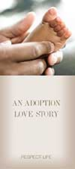
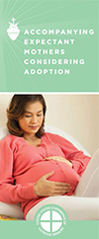
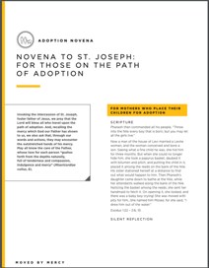
National Adoption Awareness Month
This occasion is an opportunity to highlight the gift of adoption. Resources are available to assist you in supporting and praying for all whose lives are touched by adoption:
- An Adoption Love Story
- Accompanying Expectant Mothers Considering Adoption
- Novena to St. Joseph: For Those on the Path of Adoption

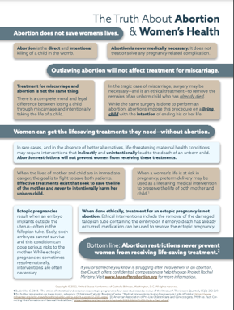
NEW! The Truth About Abortion and Women’s Health
This one-page resource dispels many myths that claim restrictions on abortion will limit women's access to life-saving care.
​This resource can be printed in parish bulletins, included in newsletters, shared on social media, and more to help educate Catholics about these false claims.
The Solemnity of Our Lord Jesus Christ, King of the Universe
November 20, 2022
Resources are being made available to help educate the faithful about the Solemnity of Christ the King and its connection to religious liberty.
20

Word of Life – November 2022
Intercessions for Life
November 1st  For all Christians:  May we look forward to the resurrection of the dead  by preparing now, in hope,  for our passage from this life into eternal life;  We pray to the Lord: | The Solemnity of All Saints
November 6th  For the sick, suffering, and those near death:  May they receive adequate care which embraces  their physical, psychological, and spiritual needs  as they journey toward eternal life;  We pray to the Lord: | Thirty-second Sunday  in Ordinary Time
November 13th  For all public officials, especially those newly elected:  May they strive to govern with the wisdom of God,  and protect life from conception to natural death;  We pray to the Lord: | Thirty-third Sunday in Ordinary Time
November 20th  For married couples considering adoption:  May the Holy Spirit guide their discernment,  grant them peace, and bring to fruition His holy will;  We pray to the Lord: | The Solemnity of Our Lord Jesus Christ, King of the Universe
November 27th  For all the faithful:  May the Lord help us build a culture of life  in vigilant expectation of His return;  We pray to the Lord: | First Sunday of Advent

Word of Life – November 2022
Bulletin Quotes
November 6th  “Death is a decisive moment in the human person’s encounter with God the Savior. Helping the Christian to experience this moment with spiritual assistance is a supreme act of charity. It encompasses the patient with the solid support of human relationships to accompany them and open them to hope. Palliative care and hospice are precious and crucial instruments in the care of patients with serious and complex chronic or terminal illnesses, and they help provide comfort to both the patients and their families.”  USCCB Secretariat of Pro-Life Activities  “The Witness of the Good Samaritan: Palliative Care and Hospice” | 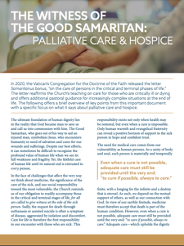  Download
November 13th  “…the Supreme Court in Dobbs cleared the way for a paradigm shift in American law, allowing it to enlarge its boundaries to again welcome a segment of the human family that had been outside of its protections for close to half a century. Dobbs, then, is a victory for justice, the rule of law, and self-governance. But for those of us who have prayed for this moment to arrive, it is the time for a renewal and rededication of our efforts to build a culture of life and civilization of love.”  Archbishop William E. Lori, Chair of the USCCB Committee on Pro-Life Activities  “Building a Culture of Life in a Post-Roe World” | 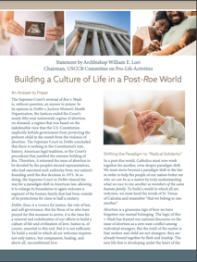  Download  Online
November 20th  “We can’t imagine loving a child whom we conceived more than we love Andrew. It is amazing how he fits our personalities so well… Adopting Andrew has made us more aware of God’s power and of his love for us. We realize that he always has a perfect plan for our lives.”  USCCB Secretariat of Pro-Life Activities,  “An Adoption Love Story” | Download  Online
November 27th  “Having received the gift of the Gospel of Life, we are the people of life and a people for life. It is our duty to proclaim the Gospel of Life to the world. To proclaim Jesus is to proclaim life itself. Gratitude and joy at the incomparable dignity of the human person impel us to bring the Gospel of life to the hearts of all people and make it penetrate every part of society.”  USCCB Secretariat of Pro-Life Activities  “The Gospel of Life: A Brief Summary” | Download | Read Online  Online

Word of Life - November 2022

Bulletin Art
You are welcome to use these and other downloadable images from the online Respect Life image gallery, provided they are not altered in any way, other than the size. Thank you!
Sunday, November 6th, 2022
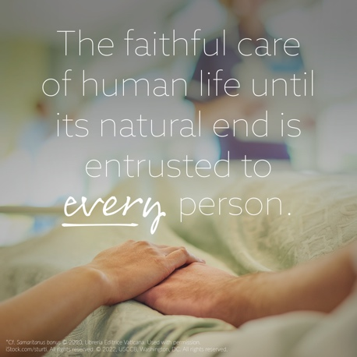
Article: “The Witness of the Good Samaritan: Palliative Care and Hospice”
Image: English | Spanish

Sunday, November 20th, 2022
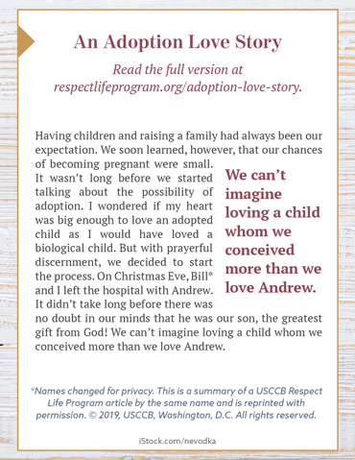
- Image (Color): English | Spanish
- Image (Grayscale): English | Spanish
- Quote Source: An Adoption Love Story (See bottom of the webpage for additional formats.)

Sunday, November 27th, 2022
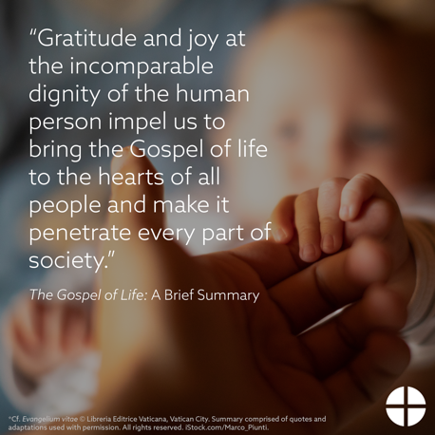
Article: The Gospel of Life: A Brief Summary
Image, Bulletin Insert PDF, and Word Doc
https://www.usccb.org/resources/gospel-life-brief-summary

