Word of Life: September 2022
Recommended dates are provided, but you are welcome to use these materials at any time!

Featured this Month…

September 9, 2022
Memorial of Saint Peter Claver, Priest
National Day of Prayer for Peace in Our Communities
St. Peter Claver was a Jesuit missionary from Spain who, in the 1600s, served and ministered to captured and enslaved Africans as they were taken off the slave ships landing in South America. St. Peter Claver desired to offer his life as “a slave of the slaves.”¹
The U.S. Catholic bishops suggest that parishes “could use the National Day of Prayer for Peace in Our Communities, which falls on the feast of St. Peter Claver (September 9), to organize activities that foster community, dialogue, and reconciliation. These encounters will help open our minds and hearts more fully and continue the healing needed in our communities and our nation.”²
The following resources are available:
- Prayer Service for the Feast Day of St. Peter Claver
- Prayer for Peace in Our Communities
- Prayer of the Faithful for the Day of Prayer for Peace in Our Communities
Additional resources are available here and in the Final Report and Recommendations from the Special Task Force to Promote Peace in Our Communities. (See page 5 and appendices A1-A3.)
¹ Collect from the Mass of Saint Peter Claver, Roman Missal, Third Edition.
² USCCB, Open Wide Our Hearts: The Enduring Call to Love, 25.
Excerpt from Roman Missal, Third Edition, © 2010 International Commission on English in the Liturgy Corporation. All rights reserved.

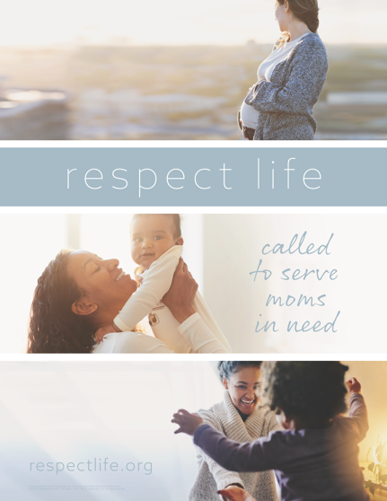
NEW!
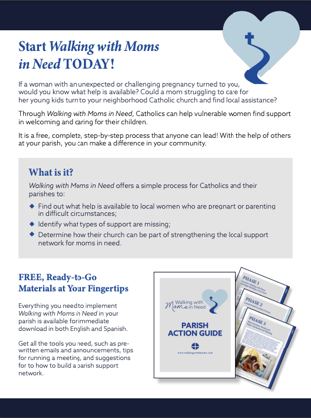
2022-2023 Respect Life Materials

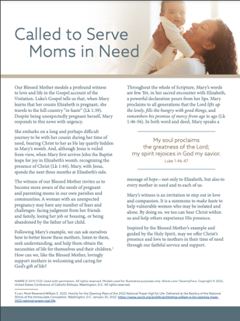
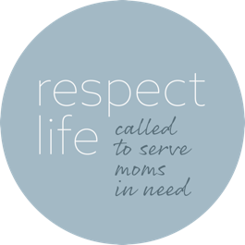
New materials are now available to help you promote the Gospel of Life. The new resources focus on our call as Catholics to serve mothers in need.
You are welcome and encouraged to use these right away. Additional materials will be provided for use specifically during Respect Life Month (October).
Find all the new resources at respectlife.org/called-to-serve.

Word of Life – September 2022
Intercessions for Life
September 4th  May the life of every human person,  from conception to natural death,  be protected in our laws  and cherished in our hearts;  We pray to the Lord: | Twenty-third Sunday  in Ordinary Time
September 11th  For solidarity and peace  in our global human family:  That we may work together  to protect the lives of those  who are most vulnerable;  We pray to the Lord: | Twenty-fourth Sunday  in Ordinary Time
September 18th  For all whose hearts ache  from participating in abortion:  may they be strengthened to seek  the Lord’s compassion, mercy, and healing  in the Sacrament of Reconciliation;  We pray to the Lord: | Twenty-fifth Sunday  in Ordinary Time
September 25th  For all who are forgotten or cast off,  especially the unborn, the poor, the sick, and the aged:  may they be treated according to the dignity  with which God created them;  We pray to the Lord: | Twenty-sixth Sunday  in Ordinary Time

Word of Life – September 2022

Bulletin Quotes
September 4th  “The Church has consistently taught that every human life is precious and worthy of protection.”  USCCB Secretariat of Pro-Life Activities  “Another Look at Abortion”  respectlife.org/another-look-at-abortion | 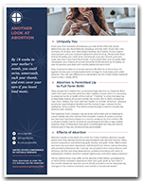  Order | Download
September 11th  “By our baptism, we are members of Christ’s body and sharers in his mission. Imitating Christ, we must care for all members of our communities, honoring each person as unique, sacred, and created in the image of God.”  USCCB, “Open Wide Our Hearts” Bulletin Insert | 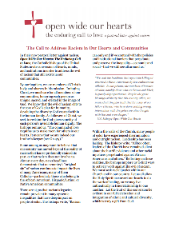  Download
September 18th  “Throughout salvation history, God has welcomed repentant sinners with special joy. Jesus concludes the parable of the lost sheep with these words: ‘there will be more joy in heaven over one sinner who repents than over ninety-nine righteous people who have no need of repentance’ (Lk 15:7)*.”  *NABRE © 2010 CCD. Used with permission.  USCCB Secretariat of Pro-Life Activities  “Life Matters: Forgiveness and Healing after Abortion” |   Order | Download
September 25th  “Suicidal individuals—with or without a terminal illness—typically do not want to die… The patient requesting assisted suicide is often asking, ‘Does anyone want me to be alive, or care enough to talk me out of this request and support me through this difficult time?’”  USCCB Secretariat of Pro-Life Activities  “Every Suicide is Tragic” | 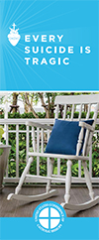  Order | Download

Word of Life - September 2022

Bulletin Art
You are welcome to use these, provided they are not altered in any way, other than the size. Thank you!
Sunday, September 4th, 2022
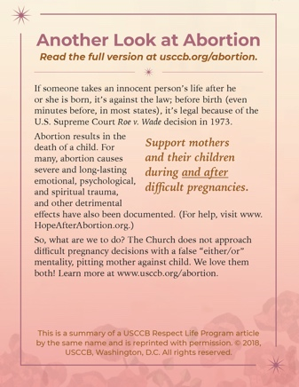
- Bulletin Box (Color): English | Spanish
- Bulletin Box (Grayscale): English | Spanish

Sunday, September 18th, 2022
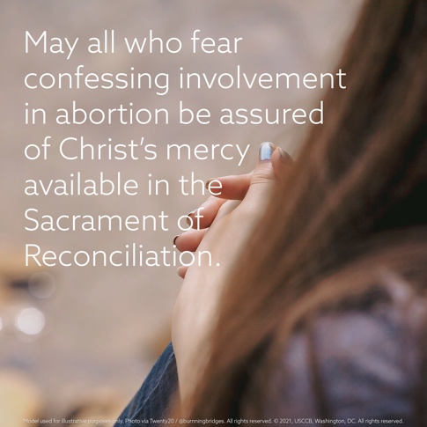
- Image: Download

Sunday, September 25th, 2022
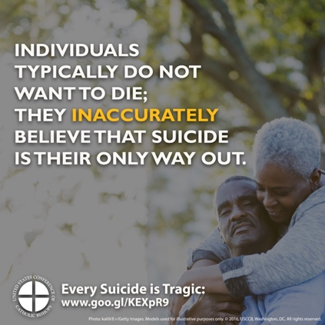
- Image: English | Spanish

