Word of Life: July 2022
Recommended dates are provided, but you are welcome to use these materials at any time!

Featured this Month

2022 Respect Life Resources: Called to Serve Moms in Need
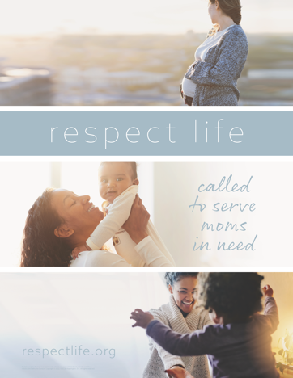
This year’s Respect Life materials focus on serving moms in need and are being released in two phases. (To be clear, a diocese or parish does not have to be in the process of launching “Walking with Moms in Need” in order to make use of this year’s materials, which highlight service to mothers.)

The first phase is being made available at www.respectlife.org/called-to-serve. You are welcome to use anything posted there immediately.

A second set of materials specifically for Respect Life Month will be released later in the summer for use during October.

National NFP Awareness Week: July 24-30, 2022
The dates of National Natural Family Planning Awareness Week highlight the anniversary of the papal encyclical Humanae vitae (July 25), which articulates Catholic beliefs about human sexuality, married love, and responsible parenthood. The dates also mark the feast of Saints Joachim and Anne (July 26), the parents of the Blessed Mother. Couples’ stories, sample intercessions, homily notes, graphics, and more can be found online.
Poster
PDF: English | Spanish JPG: English | Spanish

Feast of Saints Joachim and Anne: July 26, 2022
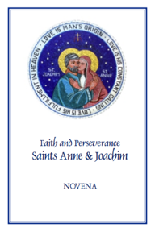
The Feast of Saints Anne and Joachim, parents of the Blessed Virgin Mary, is celebrated on July 26. They are powerful intercessors for all married couples, expectant mothers, and married couples who are having difficulty conceiving, as well as those who are aging. Copies of the “Faith and Perseverance” Novena to Saints Anne and Joachim are available for download or purchase. You can pray the novena from July 17-25 in preparation for their feast day.
Download: English | Spanish

Word of Life – July 2022
Intercessions for Life
July 3rd  For our nation:  May our laws protect  every person’s right to life,  from conception to natural death;  We pray to the Lord: | Fourteenth Sunday in Ordinary Time
July 10th  For families considering adoption:  May the Lord guide and bless their journeys  and grant them peace along the way;  We pray to the Lord: | Fifteenth Sunday in Ordinary Time
July 17th  For all those nearing death:  That their faith will grow ever stronger,  as they prepare in hope  to share eternal life with Christ;  We pray to the Lord: | Sixteenth Sunday in Ordinary Time
July 24th  May married couples embrace their call  to total, faithful, and fruitful love  with openness to new life;  We pray to the Lord: | Seventeenth Sunday in Ordinary Time
July 31st  For women who are unexpectedly pregnant:  May they be filled with trust in God’s providence  and lovingly welcome the gift of their child;  We pray to the Lord: | Eighteenth Sunday in Ordinary Time

Word of Life – July 2022

Bulletin Quotes
July 3rd  “O God our creator… through the power and working of your Holy Spirit, you call us to live out our faith in the midst of the world, bringing the light and the saving truth of the Gospel to every corner of society.”  United States Conference of Catholic Bishops  “Prayer for Religious Liberty” | 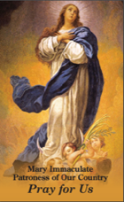  Order | Download
July 10th  “Adopting Andrew has made us more aware of God's power and of his love for us. We realize that he always has a perfect plan for our lives.”  Read more at www.bit.ly/AdoptionLoveStory.  USCCB Secretariat of Pro-Life Activities  “An Adoption Love Story” | 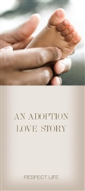  Order | Download
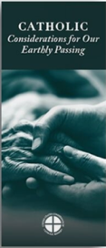
July 17th
“Because of our belief and hope in the Resurrection, we can face death not with fear, but with preparation…. We prepare for eternal life by choosing to love and follow God now, in our daily lives and decisions.” Read more at www.respectlife.org/end-of-life-considerations.
USCCB Secretariat of Pro-Life Activities
“Catholic Considerations for Our Earthly Passing”
Order | Download

July 24th  “Married love differs from any other love in the world. By its nature, the love of husband and wife is so complete, so ordered to a lifetime of communion with God and each other, that it is open to creating a new human being they will love and care for together. … That power to create a new life with God is at the heart of what spouses share with each other.”  United States Conference of Catholic Bishops  “Married Love and the Gift of Life” | Order | Download
July 31st  “A woman with an unexpected pregnancy may have any number of fears and challenges: facing judgment from her friends and family, losing her job or housing, or being abandoned by the father of her child. Following Mary’s example, we can ask ourselves how to better know these mothers, listen to them, seek understanding, and help them obtain the necessities of life for themselves and their children.”  USCCB Secretariat of Pro-Life Activities  “Called to Serve Moms in Need” | 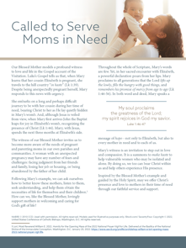  Download

Word of Life - July 2022

Bulletin Art
You are welcome to use these, provided they are not altered in any way, other than the size. Thank you!

Sunday, July 10th, 2022
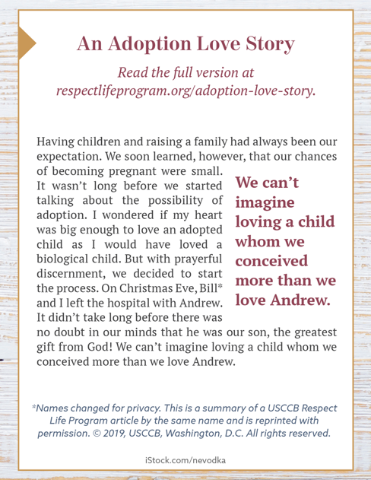
Download: English | Spanish

Sunday, July 24th, 2022
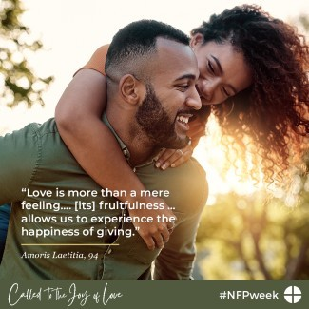
Download this and other graphics for NFP Week online.

