Word of Life: July 2020
Recommended dates are provided, but you are welcome to use these materials at any time!

Featured this Month.
Pray for Life: July
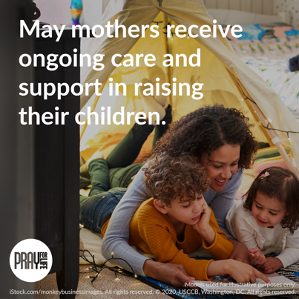
Join us in praying that mothers will receive ongoing care and support as they raise their children! walkingwithmoms.com/pray-for-moms*

Prayer Guide | Graphic
*Please note: Each month’s issue is posted the first day of the month. So, although the link currently directs to June’s issue of Pray for Life, the July issue will be posted July 1.)

National NFP Awareness Week: July 19-25, 2020
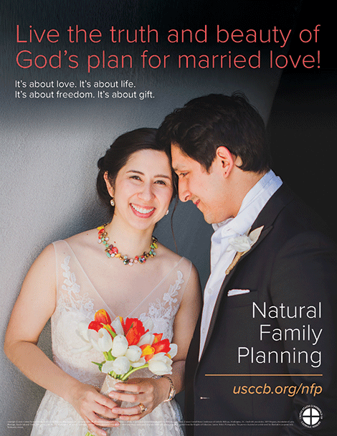
The dates of National Natural Family Planning Awareness Week highlight the anniversary of the papal encyclical Humanae vitae (July 25), which articulates Catholic beliefs about human sexuality, married love, and responsible parenthood. Couples’ stories, sample intercessions, homily notes, a media kit, and more can be found online.
Poster
PDF: English | Spanish
JPG: English | Spanish

Saints Joachim and Anne
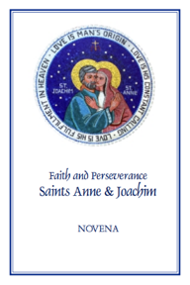
(Their memorial is not officially observed in the 2020 liturgical calendar, since July 26 – the traditional date - falls on a Sunday, which is always a solemnity and supersedes other feasts. However, the novena can still be shared for the purpose of private devotion.)
Saints Anne and Joachim, parents of the Blessed Virgin Mary, are powerful intercessors for all married couples, expectant mothers, and married couples who are having difficulty conceiving, as well as those who are aging. Copies of the “Faith and Perseverance” Novena to Saints Anne and Joachim are available for download or purchase.
Download: English | Spanish
Order: English | Spanish

Word of Life – July 2020
Intercessions for Life
July 5th  For our nation:  May our laws protect  the right to life of every human being,  from conception to natural death;  We pray to the Lord: | Fourteenth Sunday in Ordinary Time
July 12th  For families considering adoption:  May the Lord guide and bless their journey,  and grant them peace along the way;  We pray to the Lord: | Fifteenth Sunday in Ordinary Time
July 19th  May married couples embrace their call  to total, faithful, and fruitful love,  and joyful openness to new life;  We pray to the Lord: | Sixteenth Sunday in Ordinary Time
July 26th  For all those nearing death:  That their faith will grow ever stronger,  as they prepare in hope  to share eternal life with Christ;  We pray to the Lord: | Seventeenth Sunday in Ordinary Time

Word of Life – July 2020

Bulletin Quotes
July 5th  “O God our creator… through the power and working of your Holy Spirit, you call us to live out our faith in the midst of the world, bringing the light and the saving truth of the Gospel to every corner of society.”  United States Conference of Catholic Bishops  “Prayer for Religious Liberty” | 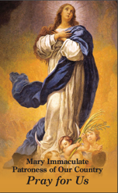  Order | Download
July 12th  “Adopting Andrew has made us more aware of God's power and of his love for us. We realize that he always has a perfect plan for our lives.”  Read more at www.bit.ly/AdoptionLoveStory.  USCCB Secretariat of Pro-Life Activities  “An Adoption Love Story” |   Order | Download

July 19th
“Married love differs from any other love in the world. By its nature, the love of husband and wife is so complete, so ordered to a lifetime of communion with God and each other, that it is open to creating a new human being they will love and care for together. … That power to create a new life with God is at the heart of what spouses share with each other.”
United States Conference of Catholic Bishops
“Married Love and the Gift of Life”
Order | Download
July 26th  “Because of our belief and hope in the Resurrection, we can face death not with fear, but with preparation…. We prepare for eternal life by choosing to love and follow God now, in our daily lives and decisions.” Read more at www.respectlife.org/end-of-life-considerations.  USCCB Secretariat of Pro-Life Activities  “Catholic Considerations for Our Earthly Passing” | 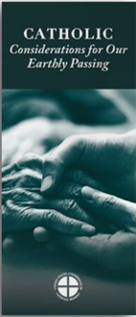  Order | Download

Word of Life - July 2020

Bulletin Art
You are welcome to use these and other downloadable images from the online Respect Life image gallery, provided they are not altered in any way, other than the size. Thank you!
Sunday, July 12th, 2020
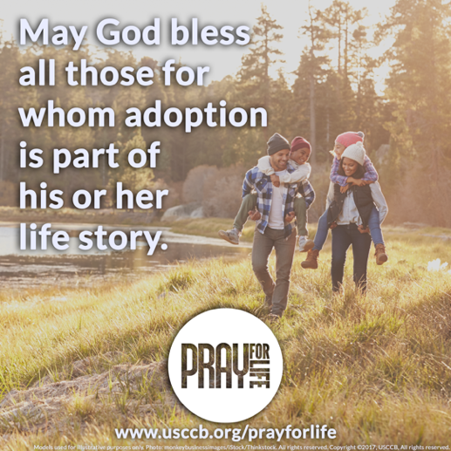
- Download Image

- Sample text to go with image: “Adopting Andrew has made us more aware of God’s power and of his love for us. We realize that he always has a perfect plan for our lives.” Read more at www.bit.ly/AdoptionLoveStory.

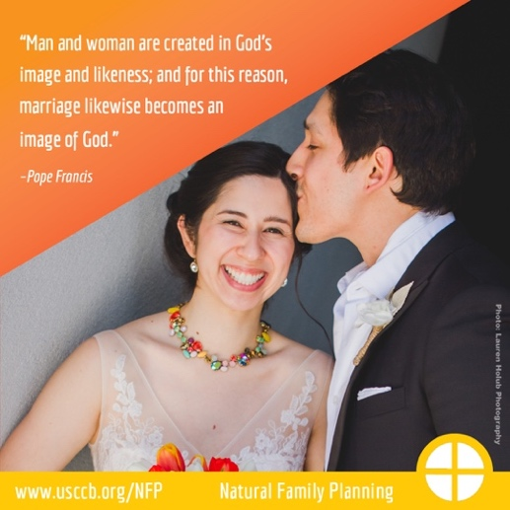
Sunday, July 19th, 2020
- Image: English | Spanish

Sunday, July 26th, 2020
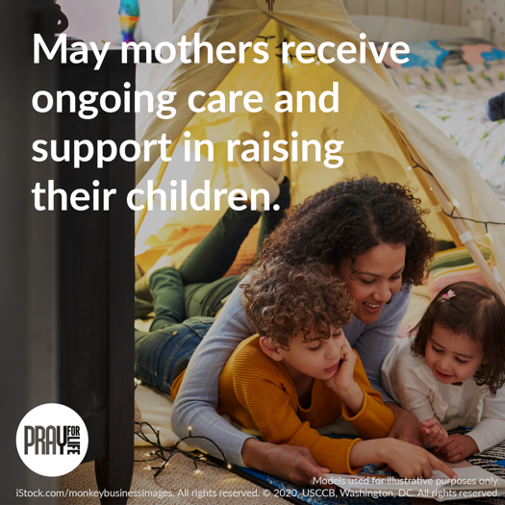
- Download Image
- Prayer Guide

